Brandreth Farms

Western Dressage Winter Celebration

February 20-22, 2026
At
Brandreth Farm
470 Brandreth Dr.
Talking Rock, GA 30175
Approved by:
WDAA #
USEF #347012 Local Competition
Opening Date: Feb 2, 2026
On Line Entries Closing date: Feb 16, 2026
Brand new for 2026 Series
Year End High Score Buckles
Open, Amateur, Youth, Therapeutic
Must attend all 4 shows

Show Information
Judge: Cindy Butler
Manager: Marie Taylor
USEF Steward: Scottie Rutherford
Safety Coordinator: Marcia Corbett
EMT: TBA
Farrier: Rusty Wright-On Call -706-290-3334
Secretary: Marie Taylor 804 314-5216 dabneymill@aol.com
Complete your entries on RingRadar.com or send to 23034 Dabney Mill Rd., N Dinwiddie, VA 23803 $25 Green Fee applies to all mailed entrys.
Make Checks Payable to: Brandreth Farms
Vet on Call
Horner & Nash 770-475-6421Our Location
From GA 400: North Bound – Exit #10 Old Milton Parkway. Go left for 4 miles to traffic light at Broadwell Road. Go right and continue .8 of a mile to intersection at Crabapple Junction. Continue through light north on 372 (Birmingham Hwy.) for 6 miles to New Bullpen Road (just past the Shell station) on left. Turn and go 1.2 miles to Antioch Road on left. Turn and go .3 of a mile to McGarity Road on left. Turn left and driveway to the barn/office is the second left.
From I – 575: North Bound – Exit #19 SR 20 East. Go right for 3.1 miles to Union Hill Road on right (just past Buffington Elementary School). Go right on Union Hill for 6.8 miles to Antioch Road on right. Turn and go .3 of a mile to McGarity Road on left. Turn left and driveway to the barn/office is the second left.
You must be a member of WDAA to ride in this show or pay a non-member fee. This will be verified prior to confirmation of your entries. You must also go through USEF Safe Sport even though you don’t have to be a member. This is a USEF Local Competition.
Management reserves the right to change officials, combine or cancel classes and modify the schedule to make whatever changes are required by circumstances to the competition specifications. Management reserves the right to refuse or require withdrawal of an entry for cause deemed sufficient by Show Management.
Class Fees:
Tests………………. $40 Therapeutic Tests are no charge
Office Fee per horse…………………………$35
USEF Drug Fee………………………………….$23
Insufficient Funds…………………………….$100
Stalls per weekend………………………....$175
No Shavings Allowed (Stalls are prebedded w/M10)
WDAA Non-Member Fee…$55 Adults, $40 Juniors
AQHA Processing Fee per horse………..$20
Camper Hookup per day……………………$30
Ribbons will be awarded 1st-4th place. Year End Championship Buckles awarded in Open and Amateur, Youth, Therapeutic all levels. The following point system will be used. 1st-6 points, 2nd -5 points, 3rd-4 points, 4th- 3 points, 5th -2 points, 6th -1 points. To be eligible for Year End Buckles, you MUST ride at all 4 shows. In addition, a High Score Award will be given at all shows for Open, Amateur, Youth in all divisions. Must ride 3 tests, exception will be the Therapeutic Division, only 1 test required. 2022 WDAA Tests will be used. Only 60 rides will be allowed. A waiting list will be used for any cancelations.
Refunds: Entries canceled with a vet certificate prior to the closing date, Feb 16,2026 will be refunded everything except the Office Fee. In the event the competition is canceled, all entry fees except the Office Fee will be refunded.
Lighting in Stable Area will be enforced from 11:00 pm to 5:00 am
GR1215.4. For six consecutive hours overnight, stabling must have minimal lighting and noise to allow stabled horses to rest adequately, which became effective December 1, 2023.
Stabling
All horses must have a stall. Requests for adjoining stalls from different owners will be honored if all entries are mailed together. No shavings are allowed in the stalls, the floor bedding is M10- which is basically Granite Dust. It has great drainage and allows the farm to thoroughly disinfect the stall floors. Stalls are 12x16 with permanent fans in each stall, elevated above the arena with full vision, full height open grid gates. Tack stalls are not available. Tack and Feed are stored across the isle way and in front of each stall.
A NEGATIVE COGGINS TEST WITHIN THE LAST 12 MONTHS MUST BE INCLUDED WITH ENTRY.
Things to Bring with you: Will be provided
A wagon to tote your items inside to your stall area. 2-Water Buckets in each stall-water only
Saddle rack Large Hay feeder in corner of stall
Grain feed pan Wheelbarrow carts to place manure in
Manure Fork
Hay & Feed for your horse
RV Hook-ups, check your power cords and hose drain are packed on your trailer.

Health Requirements – All horses entering Georgia are required to have an official health certificate within 30 days per the Board of State Veterinarians.
Show Management may, at its sole discretion, refuse an entry of an exhibitor, or the participation of, an agent, trainer, rider or handler who has shown an objectionable attitude towards a USEF Recognized competition or displayed previous unsportsmanlike behavior at a USEF Recognized competition or towards its management, as well as those persons suspended or expelled from any previous USEF Recognized competitions by USEF.
Payment of Fees – There will be a $100 charge for any returned checks. Stopping payment on checks or placing holds on credit card charges is in violation of USEF rules and an all violations will be filed with USEF.
Failure to Check Out – Prior to leaving the show grounds, please come to the show office and settle your accounts. Failure to check out at the show office will result in a non-checkout fee of $50.00.
Post Entries – Closing date is September 10, 2025 for online entries . Mailed entries must be received by that date.
Condition of Entry – The Show Committee and the Management reserves the right to refuse, accept conditionally or cancel an entry, disqualify exhibitors, prohibit exhibition of entries and remove from the grounds any individual, stable or both without claim for damages. The submitting of an entry form to the show shall constitute an acceptance by each person signing same of the provisions herein set forth.
Brandreth Farm is safe, secure and closed to the public – requiring 2 separate gate entrances with individual gate codes for participants and their guests. www.BrandrethFarms.com
You can find information on facility, arena and stall photos.
CURRENT USEF RULE BOOK WILL BE CONDUCTED AND JUDGED IN ACCORDANCE THEREWITH.” Membership Statement: Life, senior active and junior active members shall be eligible to participate in all classes at Regular Competitions, Eventing Competitions at the Modified Level or above and Combined Driving Competitions at the Advanced Level, Dressage, Reining and Vaulting Competitions and Endurance Rides. A non-member may participate as a handler, rider, driver, owner, lessee, or agent at Regular Competitions, Eventing Competitions, Dressage Competitions, Reining Competitions and Combined Driving Competitions upon payment of a Show Pass fee. Participants in the following classes are exempted from the Requirements of this rule: 1) leadline; 2) exhibitions; 3) games and races; 4) classes for 4-H members; 5) walk trot and academy classes (academy classes are classes limited to horses used regularly in a lesson program); 6) USDF introductory level tests, pas de deux and quadrille classes; 7)assistant handlers in Dressage Sport Horse Breeding classes
Protests – See USEF Chapter 6
Indemnity and Responsibility – All entries are accepted with the understanding that neither the Brandreth Farms, WDA-VA, AQHA or the Show Committee, nor any Show Official, will be held responsible for any loss, damage, or injury to any horse exhibited or any article of any kind. All horses shall be under the control and direction of the show committee but the solely at the risk of the exhibitor, who will be responsible for any loss, damage or injury to any person, animal or property occasioned by him, and the exhibitor shall indemnify the above mentioned parties against any and all loss, damages and liability thus occasioned, including but not limited to any and all legal costs, including attorney fees, which may be incurred as a result thereof.

This horse show is conducted in accordance with the rules of the USEF. The official rule book of USEF will prevail for this show. This prize list is based on rules of the current rule book and the handbook of the Arabian Horse Association, where they apply respectively; any changes or corrections of rules will automatically become a part of the prize list. Each participant is the show is responsible for knowledge of and is subject to the USEF rules. Questions not covered by USEF rules shall be decided by the show committee and its decisions will be final. By entering the show, each exhibitor agrees to abide by the final decision of the Show Committee and USEF Steward.

Directions to Brandreth Farm For GPS please use the following address:
470 Brandreth Farms Dr 640 Hamrick Rd, Jasper, GA 30143
Talking Rock, GA 30175 If using this address, drive through the first gate and past the house on the right.
(770)596-6256 go through the second gate at the end of the gravel road and follow around to the arena. Direction signs will be placed during the event.
Rings are composed of
Washed Man Made Granite

NOTICE: Anyone signing as Trainer/Coach must be a member of USEF and take Safe Sport, this includes parents.

Important Notice: All horses must be microchipped and recorded with USEF in order to be able to show.

Sharps Containers – Competition management shall place a minimum of one sharps container per each competition whether or not stabling is provided. Additionally, at least one sharps container per fifty occupied stalls for the disposal of needles and other disposable sharp instruments in convenient locations in barns housing competition horses. It is competition management’s responsibility to replace such containers when full and dispose of them properly. Competition management may fine any individuals including trainers, owners, exhibitor or their agents, up to $100 for improper disposal of needles or other sharp disposable instruments. Competition management will place a notice of this requirement either in its prize list or on a specific handout given to trainers on check in at the competition. If local law has different requirements, local law will prevail. GR 1210.4
Equine Vaccination Rule – 1. At federation licensed competitions, horses entering the grounds must be accompanied by documentation of Equine influenza Virus and Equine Herpes Virus (Rhinopneumonitis) within six months prior to entering the stables. Horses not in compliance with this rule may be required to leave the competition grounds upon request by Competition Management. Documentation should consist of one of the following methods mentioned below. The frequency of vaccine administration by or under the direction of a veterinarian. 2. In the case of vaccines administered by a veterinarian, the exhibitor, upon request by Competition Management, must provide documentation from the veterinarian on documenting that the horse in question received the vaccinations, name of the vaccines and date of vaccine administration. 3. In the case of vaccines administered by a person other than a veterinarian, the exhibitor, upon request by Competition Management, must provide a receipt of the vaccine purchase which is signed by the owner, or agent with care, custody and control of the horse, name serial number and expiration date of the vaccine and date of vaccine administration. 4.In the case of a horse that is unable to receive either of the vaccinations due to a history of adverse reactions, the exhibitor, upon request by Competition Management, must provide a letter from the veterinarian on official letterhead stating that the horse in question cannot be vaccinated due to medical concerns and a log of temperatures taken twice daily for the seven days prior to entering the competition grounds. These horses must also have their temperature taken and logged twice daily while on the competition grounds. The log of temperatures should be provided to the Competition Management, steward or technical delegate when requested. 5. Competition Management may not amend or enhance vaccination requirements without prior approval of the Veterinary Committee.
BOD 1/17/15 Effective 12/1/15
Motorized Vehicle Statement: Minors who do not have a valid driver’s license which allows them to operate a motorized vehicle in the state in which they reside will not be permitted to operate a motorized vehicle of any kind, including, but not limited to, golf carts, motorcycles, scooters, or farm utility vehicles, on the competition grounds of licensed competitions. Minors who have a valid temporary license may operate the above described motorized vehicles as long as they are accompanied by an adult with a valid driver’s license. The parent/legal guardian or individual who signs the entry blank as a parent or guardian of a minor operating a motorized vehicle in violation of this rule are solely responsible for any damages, claims, losses or actions resulting from that operation. Violations of this rule will be cause for penalties against those responsible for the child committing the offense. Wheelchairs and other mobility assistance devices for individuals with disabilities are exempt from this rule. The unsafe use of personal electronic transport devices, as determined by the competition officials and management in their sole discretion, that do not require a driver’s license to operate, including but not limited to segways, hover boards, and single wheeled scooters is prohibited on competition grounds. Operating such devices in areas where people gather may be deemed “unsafe use” if there is a risk of harm to others. If the operator of the device is a minor, the parent/legal guardian or individual who signs the entry blank as a parent or guardian of a minor operating the device in violation of this rule is accountable and may be subject to penalties. Wheelchairs and other mobility assistance devices for individuals with disabilities are exempt from this rule.
Open/AQHA Western Dressage Feb 20-22,2026
Friday Saturday Sunday Class Name
2000 3000 4000 WDAA Intro Level Test 1 Open
2001 3001 4001 WDAA Intro Level Test 1 Amateur
2002 3002 4002 WDAA Intro Level Test 1 Youth/Junior
2003 3003 4003 WDAA Intro Level Test 2 Open
2004 3004 4004 WDAA Intro Level Test 2 Amateur
2005 3005 4005 WDAA Intro Level Test 2 Youth/Junior
2006 3006 4006 WDAA Intro Level Test 3 Open
2007 3007 4007 WDAA Intro Level Test 3 Amateur
2008 3008 4008 WDAA Intro Level Test 3 Youth/Junior
2009 3009 4009 WDAA Intro Level Test 4 Open
2010 3010 4010 WDAA Intro Level Test 4 Amateur
2011 3011 4011 WDAA Intro Level Test 4 Youth/Junior
2012 3012 4012 WDAA Basic Level Test 1 Open
2013 3013 4013 WDAA Basic Level Test 1 Amateur
2014 3014 4014 WDAA Basic Level Test 1 Youth/Junior
2015 3015 4015 WDAA Basic Level Test 2 Open
2016 3016 4016 WDAA Basic Level Test 2 Amateur
2017 3017 4017 WDAA Basic Level Test 2 Youth/Junior
2018 3018 4018 WDAA Basic Level Test 3 Open
2019 3019 4019 WDAA Basic Level Test 3 Amateur
2020 3020 4020 WDAA Basic Level Test 3 Youth/Junior
2021 3021 4021 WDAA Basic Level Test 4 Open
2022 3022 4022 WDAA Basic Level Test 4 Amateur
2023 3023 4023 WDAA Basic Level Test 4 Youth/Junior
2024 3024 4024 WDAA Level 1 Test 1 Open
2025 3025 4025 WDAA Level 1 Test 1 Amateur
2026 3026 4026 WDAA Level 1 Test 1 Youth/Junior
2027 3027 4027 WDAA Level 1 Test 2 Open
2028 3028 4028 WDAA Level 1 Test 2 Amateur
2029 3029 4029 WDAA Level 1 Test 2 Youth/Junior
2030 3030 4030 WDAA Level 1 Test 3 Open
2031 3031 4031 WDAA Level 1 Test 3 Amateur
2032 3032 4032 WDAA Level 1 Test 3 Youth/Junior
2033 3033 4033 WDAA Level 1 Test 4 Open
2034 3034 4034 WDAA Level 1 Test 4 Amateur
2035 3035 4035 WDAA Level 1 Test 4 Youth/Junior
2036 3036 4036 WDAA Level 2 Test 1 Open
2037 3037 4037 WDAA Level 2 Test 1 Amateur
2038 3038 4038 WDAA Level 2 Test 1 Youth/Junior
2039 3039 4039 WDAA Level 2 Test 2 Open
2040 3040 4040 WDAA Level 2 Test 2 Amateur
2041 3041 4041 WDAA Level 2 Test 2 Youth/Junior
2042 3042 4042 WDAA Level 2 Test 3 Open
2043 3043 4043 WDAA Level 2 Test 3 Amateur
2044 3044 4044 WDAA Level 2 Test 3 Youth/Junior

Open/AQHA Western Dressage Cont Feb 20-22, 2026
Friday Saturday Sunday Class Name
2045 3045 4045 WDAA Level 2 Test 4 Open
2046 3046 4046 WDAA Level 2 Test 4 Amateur
2047 3047 4047 WDAA Level 2 Test 4 Youth/Junior
2048 3048 4048 WDAA Level 3 Test 1 Open
2049 3049 4049 WDAA Level 3 Test 1 Amateur
2050 3050 4050 WDAA Level 3 Test 1 Youth/Junior
2051 3051 4051 WDAA Level 3 Test 2 Open
2052 3052 4052 WDAA Level 3 Test 2 Amateur
2053 3053 4053 WDAA Level 3 Test 2 Youth/Junior
2054 3054 4054 WDAA Level 3 Test 3 Open
2055 3055 4055 WDAA Level 3 Test 3 Amateur
2056 3056 4056 WDAA Level 3 Test 3 Youth/Junior
2057 3057 4057 WDAA Level 3 Test 4 Open
2058 3058 4058 WDAA Level 3 Test 4 Amateur
2059 3059 4059 WDAA Level 3 Test 4 Youth/Junior
2060 3060 4060 WDAA Level 4 Test 1 Open
2061 3061 4061 WDAA Level 4 Test 1 Amateur
2062 3062 4062 WDAA Level 4 Test 1 Youth/Junior
2063 3063 4063 WDAA Level 4 Test 2 Open
2064 3064 4064 WDAA Level 4 Test 2 Amateur
2065 3065 4065 WDAA Level 4 Test 2 Youth/Junior
2066 3066 4066 WDAA Level 4 Test 3 Open
2067 3067 4067 WDAA Level 4 Test 3 Amateur
2068 3068 4068 WDAA Level 4 Test 3 Youth/Junior
2069 3069 4069 WDAA Level 4 Test 4 Open
2070 3070 4070 WDAA Level 4 Test 4 Amateur
2071 3071 4071 WDAA Level 4 Test 4 Youth/Junior
2072 3072 4072 WDAA Therapeutic Riding Test Leadline A Walk Only
2073 3073 4073 WDAA Therapeutic Riding Test Coached Test 1 Walk
2074 3074 4074 WDAA Therapeutic Riding Test of Choice

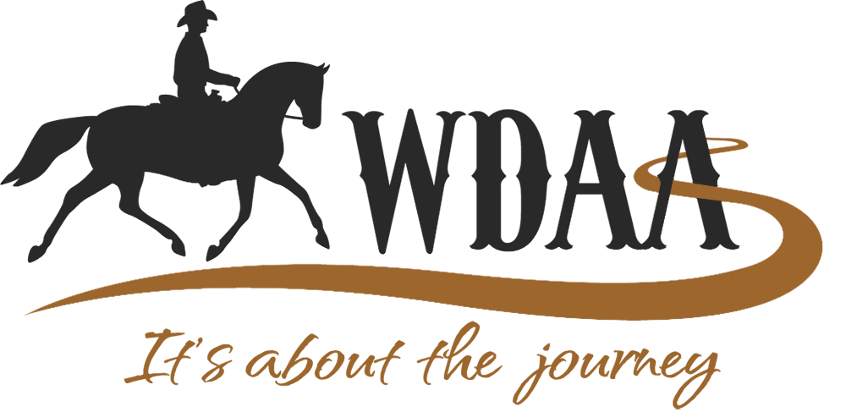

Key Requirements for WDAA Recognized Shows
1. Show Entry Form Requirements
To ensure accurate results submission, entry forms must include fields to collect the following information:
• Exhibitor Name and WDAA Membership Number______________________________
Horse Name________________________________________
Horse Identification Number, which may include 1 or all of the following.
USEF-assigned Horse Number_________________________
WDAA-assigned Horse Number________________________
Breed Registration Number____________________________
Recognizing your Efforts in 2026  We’ve worked closely with many of you during the 2024 season and are pleased to share that most shows already use accepted file formats for show results.  If your show submitted results for the 2024 competition year with both WDAA Member Numbers and Horse Identification, your 2025 WDAA Recognized shows are eligible to claim the YEHP Ready badge! |  | 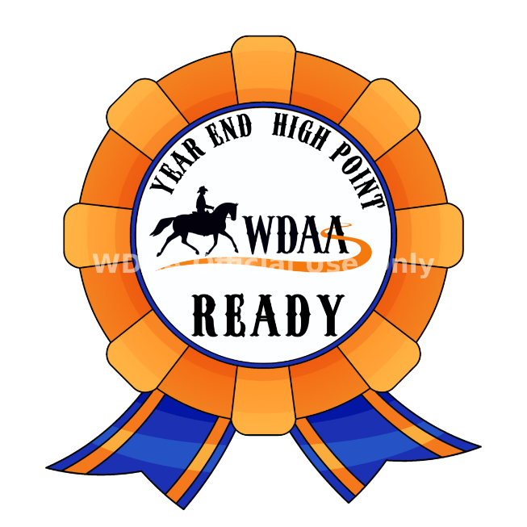

“EVERY CLASS OFFERED HEREIN WHICH IS COVERED BY THE RULES AND SPECIFICATIONS OF THE CURRENT USEF RULE BOOK WILL BE CONDUCTED AND JUDGED IN ACCORDANCE THEREWITH.”

Membership Statement:
Life, senior active and junior active members shall be eligible to participate in all classes at Regular Competitions, Eventing Competitions at the Modified Level or above and Combined Driving
Competitions at the Advanced Level, Dressage, Reining and Vaulting Competitions and Endurance Rides. A non-member may participate as a handler, rider, driver, owner, lessee, or agent at Regular Competitions, Eventing Competitions, Dressage Competitions, Reining Competitions and Combined Driving Competitions upon payment of a Show Pass fee. Participants in the following classes are
exempted from the Requirements of this rule: 1) leadline; 2) exhibitions; 3) games and races; 4) classes for 4-H members; 5) walk trot and academy classes (academy classes are classes limited to horses used regularly in a lesson program); 6) USDF introductory level tests, pas de deux and quadrille classes; 7)assistant handlers in Dressage Sport Horse Breeding classes
Safe Sport Reminder:
Reminder: All USEF Life and Senior Active members, as well as participants who have regular contact with minor athletes, are required to comply with the U.S. Center for SafeSport training requirement to be eligible to participate in the competition. All participants must adhere to the U.S. Center for SafeSport Code, USEF Safe Sport Policy, and the Minor Athlete Abuse Prevention Policies. More information
about these can be found at www.usef.org.

Motorized Vehicle Statement:
Minors who do not have a valid driver’s license which allows them to operate a motorized
vehicle in the state in which they reside will not be permitted to operate a motorized vehicle of any kind, including, but not limited to, golf carts, motorcycles, scooters, or farm utility vehicles, on the competition grounds of licensed competitions. Minors who have a valid temporary license may operate the above described motorized vehicles as long as they are accompanied by an adult with a valid driver’s license. The parent/legal guardian or individual who signs the entry blank as a parent or guardian of a minor operating a motorized vehicle in violation of this rule are solelyresponsible for any damages, claims, losses or actions resulting from that operation. Violations of this rule will be cause for penalties against those responsible for the child committing the offense. Wheelchairs and other mobility assistance devices for individuals with disabilities are exempt from this rule.The unsafe use of personal electronic transport devices, as determined by the competitionofficials and management in their sole discretion, that do not require a driver’s license to operate, including but not limited to segways, hover boards, and single wheeled scooters is prohibited on competition grounds. Operating such devices in areas where people gather may be deemed“unsafe use” if there is a risk of harm to others. If the operator of the device is a minor, the parent/legal guardian or individual who signs the entry blank as a parent or guardian of a minor operating the device in violation of this rule is accountable and may be subject to penalties.Wheelchairs and other mobility assistance devices for individuals with disabilities are exempt from this rule.
WDAA Membership Statement
To be eligible to participate and/or compete as an exhibitor, owner, lessee, agent, coach, or trainer in any Federation-Licensed Western Dressage class or competition, persons must be active members of WDAA or pay a non-member fee equal to the price of an annual membership for each competition. Exception: WDAA membership or non-member fee is not required at a Lite Licensed competition. Lessees are considered owners in connection with this membership requirement. In the event of an entry under multiple ownership, only one owner need be a member or pay a non-member fee. The competition is responsible for listing either the active member or the owner that paid the non-member fee in the results. The competitions will be responsible for forwarding a list of the names of individuals who pay non-member fees at the competition to WDAA with the post competition report. Payment of non-member fees for the purpose of competing does not entitle the individual to any privileges of the WDAA membership.

WDAA Mission Statement
The Western Dressage Association of America is an Educational Not for Profit with a 501c3 status. Our primary focus is on education about and the promotion of Western Dressage. Our mission is to build an equine community that combines the Western traditions of horse and rider with classical dressage. We honor the horse. We value the partnership between horse and rider. We celebrate the legacy of the American West. It’s about the journey! Visit our website at westerndressageassociation.org for information about our educational and award programs and membership benefits.

